Written by:

Adil Anwar

Architecture Design

Budget Sales

Analysis

Revision Number – 1.1

Last Date of Revision : 25-10-2022

Written by:

Adil Anwar
Document Version Control

Date | Version | Description | Author
18-10-2022 | 1.0 | Abstract  Introduction  Architecture | Adil Anwar
25-10-2022 | 1.1 | Architecture Design | Adil Anwar

1. Introduction

1.1 What is Architecture design document?

Any software needs the architectural design to represents the design of software. IEEE defines architectural design as “the process of defining a collection of hardware and software components and their interfaces to establish the framework for the development of a computer system.” The software that is built for computer-based systems can exhibit one of these many architectures. Each style will describe a system category that consists of :

- A set of components (eg: a database, computational modules) that will perform a function required by the system.

- The set of connectors will help in coordination, communication, and cooperation between the components.

- Conditions that how components can be integrated to form the system.

- Semantic models that help the designer to understand the overall properties of the system.
1.2 Scope

Architecture Design Document (ADD) is an architecture design process that follows a step-by-step refinement process. The process can be used for designing data structures, required software architecture, source code and ultimately, performance algorithms. Overall, the design principles may be defined during requirement analysis and then refined during architectural design

Power BI Architecture

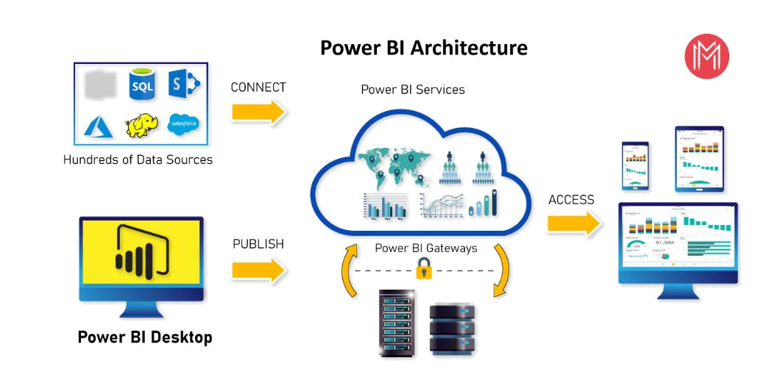

Microsoft Power BI Architecture:

Power BI is a business platform that includes several technologies to work together. It delivers outstanding business intelligence solutions. Power BI Architecture contains four steps.

Let us discuss these four steps giving insightful information about each one of them.

  - Data Integration

  - Data Transforming

  - Report & Publish

  - Creating and Dashboard

- Data Integration:

Data is extracted from different sources which can be different servers or databases. The data from various sources can be in

different types and formats. If you import the file into the Power BI, it compresses the data sets up to 1GB, and it uses a direct query if the compressed data sets exceed more than 1GB. Then the data is integrated into a standard format and stored at a place called a staging area. There are two choices for big data sets. They are as follows.

Azure Analytics Services

Power BI premium

- Data Transforming:

Integrated data is not ready to visualize data because the data should be transformed. To transform the data, it should be cleaned or pre-processed. For example, redundant or missing values are removed from the data sets. After data is pre-processed or cleaned, business rules are applied to transform the data. After processing the data, it is loaded into the data warehouse.

3. Report & Publish:

After sourcing and cleaning the data, you can create the reports. Reports are the visualization of the data in the form of slicers, graphs, and charts. Power BI offers a lot of custom visualization to create the reports. After creating reports, you can publish them to power bi services and also publish them to an on-premise power bi server.

4. Creating Dashboards:

You can create dashboards after publishing reports to Power BI services, by holding the individual elements. The visual retains the filter when the report is holding the individual elements to save the report. Pinning the live report page allows the dashboard users to interact with the visual by selecting slicers and filters.
Components of Power BI Architecture:

Let us learn the components of Power BI Architecture in detail.
Here is the list of components.

These components play an important role in delivering the Power BI capabilities. Now, let’s discuss the Components of Power BI Architecture.

#1. Data Sources


Power BI can supply information from different online sources and file types. Import the information into the Power BI or establish a live service to receive the information. If you import the file into the Power BI, it compresses the data sets up to 1GB and, uses a direct query if the compressed data sets exceed more than 1GB. Here is the list of Data Sources supported in Power BI.

Here is the list of Data Sources supported in Power BI.

File Types: Power BI supports XML, txt/CSV, Excel, JSON, and Share point folder type files.

Database: It supports SQL Server Analysis Services Database, SAP HANA Database, SQL Server Database, SAP Business Warehouse server, Access Database, Google BigQuery (Beta), Amazon Redshift, Snowflake, Impala, Oracle Database, IBM Informix database (Beta),

Teradata Database, MySQL Database, IBM Netezza (Beta), Sybase Database, PostgreSQL Database.

Azure: Azure SQL Data Warehouse, Azure Blob Storage, Azure Analysis Services database (Beta), Azure SQL Database, Azure Data Lake Store, Azure Table Storage, Azure HDInsight (HDFS), Azure Cosmos DB (Beta), Azure HDInsight Spark (Beta).

Online Services: Power BI service, Dynamics 365 (online), Microsoft Exchange Online, Common Data Service (Beta), SharePoint Online List, Visual Studio Team Services (Beta), Dynamics 365 for Financials (Beta), Microsoft Azure Consumption Insights (Beta), Salesforce Objects, Salesforce Reports, Google Analytics, Dynamics 365 for Customer Insights (Beta), GitHub (Beta), appFigures (Beta), comScore Digital Analytix (Beta), Facebook, Kusto (Beta), Planview Enterprise (Beta), MailChimp (Beta), Mixpanel (Beta), QuickBooks Online, Projectplace (Beta).

Other Services: Hadoop File (HDFS), Vertica (Beta), Web, OData Feed, SharePoint List, Microsoft Exchange, Active Directory, R Script, ODBC, Spark (Beta), Blank Query, OLE DB.

#2. Power BI Desktop
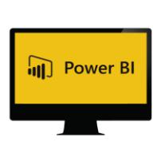

It is free software that enables you to connect, transform and visualize the data on your desktop. You can connect to various data sources with the help of Power BI Desktop and combine the data into a data model. This data model allows you to create a collection of images and graphics that make you share the information within the organization as records. The majority of the users who work on Business Intelligence projects use Power BI Desktop to create and share their reports with others.

#3. Power BI Service


Power BI Service is an On-Cloud service with a web-based platform and used to share and publish the reports made on Power BI Desktop. It collaborates the data with other users and creates dashboards. Power BI Service is also called “Power BI Workspace”, “Power BI Web Portal”, and “Power BI Site”. Power BI Service offers wonderful features like alerts and natural language Q&A.
It is available in three versions. They are as follows:

Premium version

Pro version

Free version

#4. Power BI Report Server


Power BI Report Server is similar to the Power BI Service. It is an On-Premises server platform. Using Power BI Report Server, organizations can secure their data. It enables the users to create reports and dashboards and allows you to share the reports with other users or organizations with proper security protocols. To use this service, you need to have a Power BI premium license.

#6. Power BI Mobile Apps


Using Power BI Mobile Apps, you can stay connected with on-premises data from anywhere. Power BI apps are available for iOS, Windows, and Android platforms.
#7. Power BI Embedded


Power BI Embedded is an On-premises service in Azure. It offers APIs for embedding the reports and dashboards into custom applications. Till now, we have been discussing major components of the Power BI, and now, we will talk about the remaining components of Power BI as well.

Here is the list of the remaining Power BI Components. #8. Power BI Query


Power Query is the data connectivity that enables the business users to access the data which is stored in multiple data sources and redesign it to satisfy their business requirements. Power Query offers custom connectors SDK so that third-party users can create their data connectors.

Power BI Architecture - Working
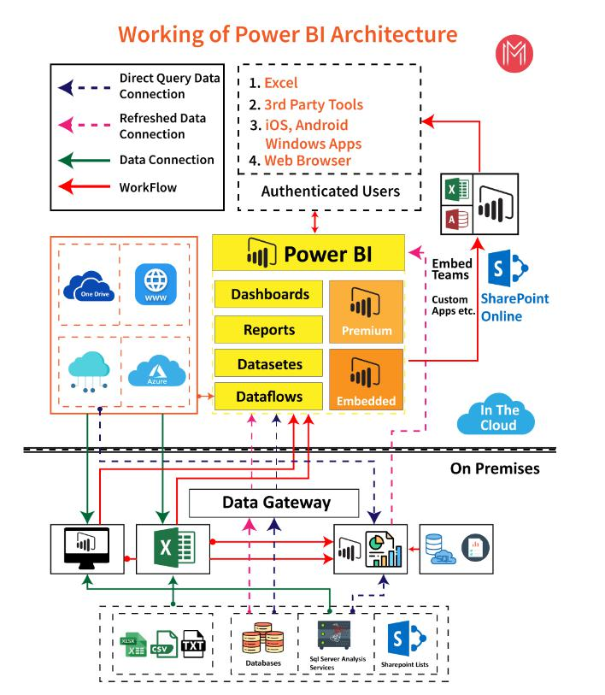
Conclusion:

Now we have detailed information about the Power BI Architecture, its working, and its components. And also, we have explained the Power BI service and its works.

